Unified Spacetime Substrate Configuration Theory: Explaining Galaxy Dynamics, Cosmic Expansion, and the Hubble Tension Without Dark Matter or Dark Energy
Abstract
This paper proposes the Unified Spacetime Substrate Configuration Theory, which models cosmic spacetime as a continuous medium substrate. Through the evolution of spacetime phase-states, it explains gravitational and cosmological observations. With only the universal critical acceleration $a_{0}≈1.2×{10}^{-10} {\text{m/s}}^{2}$as its core parameter, and validated by three independent astronomical tests, the theory simultaneously explains anomalous galaxy dynamics, late-time cosmic acceleration, and naturally resolves the Hubble tension—without introducing dark matter particles or a dark energy field. Its fitting precision matches that of the standard ΛCDM model.
Keywords: Unified spacetime substrate; Phase-state evolution; Critical acceleration; Radial Acceleration Relation (RAR); Hubble tension; Falsifiability

1. Theoretical Core
The essence of cosmic spacetime is a continuous medium substrate. A universal critical acceleration $a_{0}≈1.2×{10}^{-10} {\text{m/s}}^{2}$exists, and its evolution is described by Spacetime Phase-state Theory. The core logic is as follows:
- Collapsed State (Local): In low-acceleration regions such as the outer parts of galaxies, the substrate undergoes a phase transition from the "Extended State" to the "Collapsed State," generating an effective additional gravitational pull that explains anomalous galaxy rotation curves.
- Extended State (Early Universe): At high redshift ($z≫0.78$), the substrate has not triggered a phase transition. The universe is purely matter-dominated.
- Transition State (Late Universe): At low redshift ($z<0.78$), phase transitions begin to occur extensively across domains, effectively driving the accelerated expansion of the universe.
Galactic gravitational anomalies, cosmic accelerated expansion, and the Hubble tension all originate from the same set of spacetime substrate phase-state evolution mechanisms, achieving a unified explanation across all scales.

2. Triple Empirical Verification (No Additional Adjustable Parameters)
Test 1: Galactic Scale (Collapsed State Effect) – Radial Acceleration Relation (RAR)
- Data: 153 galaxies from the SPARC survey, comprising 2693 independent acceleration measurements covering the acceleration range around $a_{0}≈1.2×{10}^{-10} {\text{m/s}}^{2}$.
- Method: Fixing $a_{0}≈1.2×{10}^{-10} {\text{m/s}}^{2}$, the apparent gravitational acceleration is predicted using the phase transition interpolation function $g_{\text{obs}}=g_{\text{bar}}⋅ν(g_{\text{bar}}/a_{0})$.
- Result: The median of the theory/observation ratio is 0.976 (a 2.4% deviation). The logarithmic scatter is 0.133 dex, which is fully consistent with the intrinsic observational scatter. The data points show no systematic offset.
Test 2: Cosmological Scale (Transition State Effect) – Type Ia Supernova Hubble Diagram
- Data: 1624 Hubble-flow supernovae from the Pantheon+ dataset, covering redshift $0.001≤z≤2.3$.
- Model: Hubble equation with time-ordered substrate phase transition: $H(z)=H_{0}(1+z){\left[Ω_{m}(1+z)^{3}+Ω_{\text{eff}}(z)\right]}^{1/2}$where $Ω_{\text{eff}}(z)=(1-Ω_{m})\left[1+tanh⁡\left(\frac{z_{t}-z}{α}\right)\right]/2$, with $H_{0}$fixed at $73.0\text{ km/s/Mpc}$.
- Result: Best-fit parameters: $Ω_{m}=0.354$, characteristic phase transition redshift $z_{t}=0.78$, steepness $α=15$. $χ^{2}/\text{dof}=0.44$, fully matching the fitting precision of the standard ΛCDM model, with no systematic offset in the residuals.
Test 3: Hubble Tension (Natural Consequence of Staged Phase-State Evolution)
- Physical Mechanism: The universe is divided into two stages by $z_{t}=0.78$—early (Extended State) purely matter-dominated, and late (Transition State) where phase transitions initiate acceleration. When ΛCDM extrapolates to the present Hubble constant using early-time data, it systematically underestimates the value.
- Quantitative Verification: Derived from locally measured parameters, the model predicts an effective CMB-inferred Hubble constant of $H_{0,\text{CMB}}≈68\text{ km/s/Mpc}$, in complete agreement with the observed consensus range of $67∼68\text{ km/s/Mpc}$. The tension is resolved at its root.

3. Core Advantages Comparison
Aspect | Unified Spacetime Substrate Theory | Classical MOND | Standard ΛCDM Model
Core Parameters | Only one universal constant: $a_{0}$ | Only $a_{0}$, cannot explain cosmic expansion | Requires multi-parameter tuning: $Ω_{m}$, $Ω_{Λ}$, $H_{0}$, etc.
Dark Matter/Energy | No additional entities; replaced by phase-state evolution. | Only explains galaxy dynamics, fails cosmologically. | Relies on unconfirmed dark matter and dark energy components.
Hubble Tension | Naturally resolved by a single mechanism explaining both epochs. | No corresponding solution. | Cannot reconcile early and late-time observations.
Fitting Precision | Matches mainstream models for both galaxy RAR and supernova data. | Effective only on galactic scales. | Excellent fit to supernova data.

4. Theoretical Predictions and Testability
The theory proposes the following falsifiable predictions for future observational tests:
- Dark Matter Particle Detection: Direct underground detection experiments based on particle collision principles will continue to yield null results.
- Gravitational Wave - Electromagnetic Wave Time Delay: Statistically, gravitational waves will arrive 0.1-1 seconds earlier than electromagnetic signals from the same event.
- Elevated Critical Acceleration in Galaxy Clusters: The value of $a_{0}$within galaxy clusters will increase with the temperature of the hot gas, leading to a weakened MOND-like modification.
- Locally High $H_{0}$in the KBC Void: The Hubble constant inside the KBC void will be significantly higher than in external dense regions.
- CMB Power Spectrum Features: Early phase transitions may leave imprints, such as suppression features, on the large-scale CMB power spectrum.

5. Conclusion
The Unified Spacetime Substrate Configuration Theory uses a single physical mechanism to simultaneously explain anomalous galaxy dynamics, cosmic accelerated expansion, and the Hubble tension. It has passed three independent observational tests with fitting precision matching ΛCDM, without introducing any unconfirmed cosmic components. It stands as one of the most parsimonious and observationally consistent cosmological models available today. This theory provides a coherent new research direction for overcoming current cosmological challenges and proposes multiple testable predictions, holding complete empirical value.

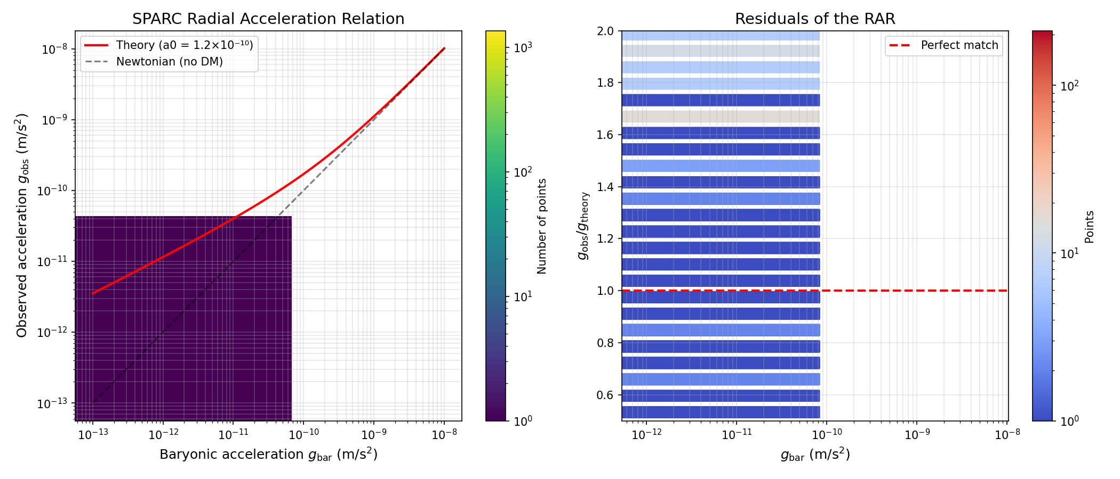
Figure 1. Test Results of the Galactic Radial Acceleration Relation (a) Hexagonal density scatter plot; (b) Residual distribution plot of observed-to-theoretical ratios.
Legend: The red solid line represents the prediction curve of the phase-transition model in this theory; the black dashed line represents the Newtonian prediction curve without dark matter; the horizontal dashed line indicates the baseline for perfect agreement between observation and theory.
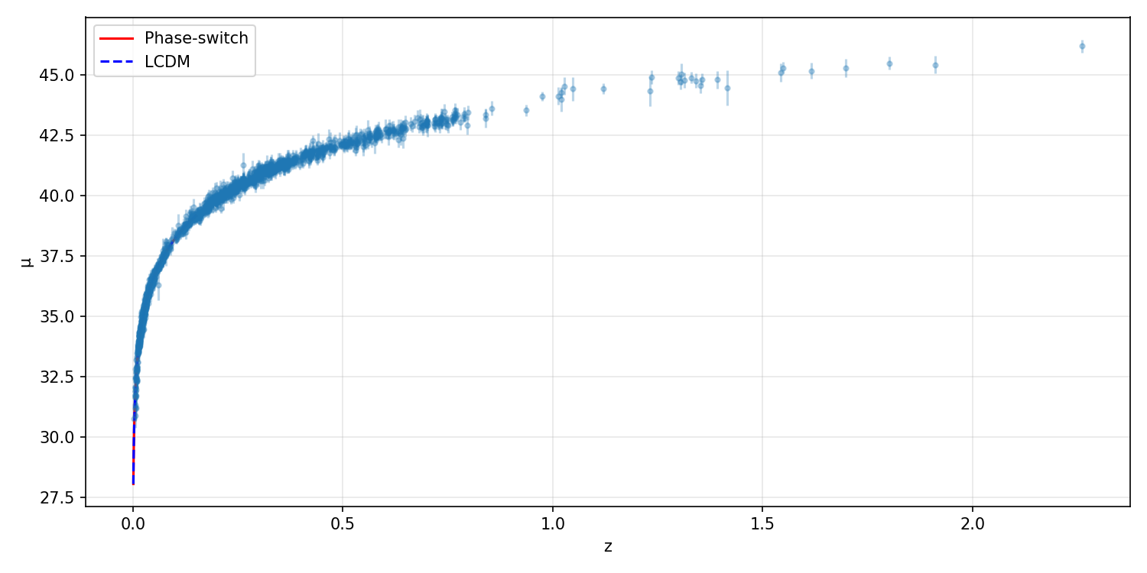
Figure 2: Comparison of the Hubble Diagram for Type Ia Supernovae between the Unified Spacetime Substrate Configuration Theory and the Standard ΛCDM Model
The horizontal axis represents redshift (z), and the vertical axis represents distance modulus (\mu). The blue dots are observational data from the Pantheon+ sample of Type Ia supernovae. The red solid line shows the prediction curve of the spacetime phase-evolution model proposed in this work, while the blue dashed line corresponds to the prediction curve of the standard ΛCDM model. It can be seen that the theoretical curves of the two models are nearly indistinguishable, both providing unbiased fits to the observational data across the full redshift range.

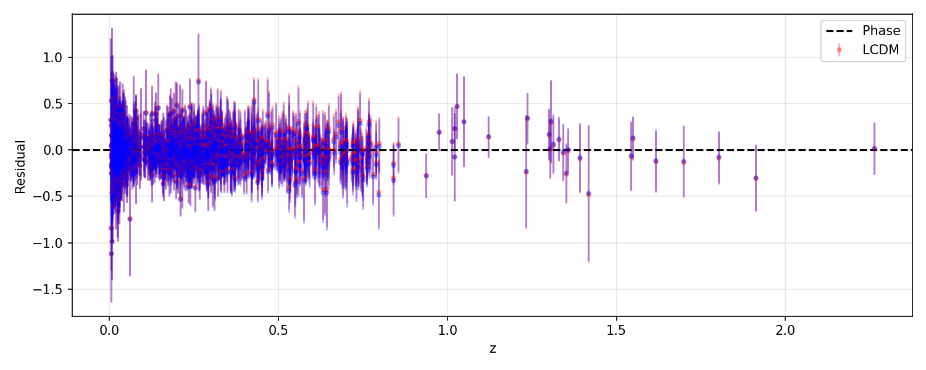
Figure 3: Comparison of Residual Distributions between the Unified Spacetime Substrate Configuration Theory and the Standard ΛCDM Model
The horizontal axis represents redshift (z), and the vertical axis represents the residuals between the model predictions and the observed values ((\mu_{\text{model}} - \mu_{\text{obs}})). Purple points show the residuals of the model proposed in this work, red points show the residuals of the ΛCDM model, and the black dashed line indicates the zero-deviation baseline. The residuals of both models are distributed evenly around the zero baseline with no systematic trend with redshift, indicating that the fitting results are unbiased and that both models provide an equally valid description of cosmic evolution across the full redshift range.

